**REVISION OF GARDE 3 – SCHOOL YEAR 2019-2020**

❄ **Content:** Students learn by heart all the words from Unit 1 to Unit 6, Unit 7.

❄ **Grammar:** Students review the following structures:

a. What time is it? It is twelve o’clock.

b. What do you like? I like balloons.

c. What does Sean like? He likes toys.

d. What do we have on Monday? We have English.

e. Do you have a milkshake? Yes, I do / No, I don’t.

Does Vicky have noodles? Yes, she does / No, she doesn’t.

f. How many boards are there? There are fifteen boards.

g. This is a new computer / That is an old egg.

These are tall trees / Those are small chairs.

**READING AND WRITING:**

**I. Read and choose the correct words, then write them on the lines:**

**coins spoon winter a camel a forest shells clowns**

1.This animal lives in desert. It helps people to carry heavy things. _______

2. You often see them when you go to the circus. _______

3.You can find a lot of trees and animals here. _______

4. It’s very cold in this season. You have to wear a coat. _______

5. You like collecting these things at the beach. They’re colorful. _______

6. You have to buy these when you play games at the mall. _______

**II. Read the box and choose the correct verb:**

**goes catches a bus cooks likes get brushes**

**surf brush write collect**

1. Sam _______ taking photos a lot. He often _________ to the zoo to take photos of the animals.

2. Vicky ________ her teeth every morning. Then, she _______ a bus to school.

3. Mom and Dad ________ up early in the morning. My mom _______ breakfast for my family.

**III. Read the text and circle the best answer:**

1.John: Which sports do you like playing ?

Jack: A. waterskiing, maybe

B. Not at all

C. I’m sure

2. Tom: Can I go fishing, dad?

Dad: A. Every afternoon, Tom.

B. Last time, Tom.

C. Sure, Tom.

3. Jane: When do you have breakfast?

Jill : A . I have it at 9 a.m

B. It isn’t late.

C. I has it at 9 a.m

**IV. Unscramble the words:**

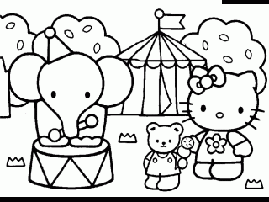1.

**o z o**

**i r a o p r t**

**p o r t**

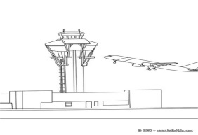2.

3.

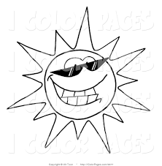

4.

__ __ __

__ __ __ __ __ __

**n a k b**

__ __ __ _

**u n n y s**

__ __ __ __ __

**V. Answer the questions:**

1. What do you like ? .........................................

2. What time is it?

........................................

__ __ __ __ __

**ANSWER KEYS:**

**I. Read and choose the correct words, then write them on the lines:**

1. a camel 2. clowns 3. a forest 4. winter 5. shells 6. Coins

**II. Read the box and choose the correct verb:**

1. likes – goes 2. brushes – catches 3. get – cooks

**III. Read the text and circle the best answer:**

1A 2C 3A

**IV. Unscramble the words:**

1.zoo 2.airport 3.plane 4. sunny

**V. Answer the questions:**

1. I like balloons/ cakes / apples ....

2. It is one o’clock / It is two o’clock....